Project Initiation Document

(PID)

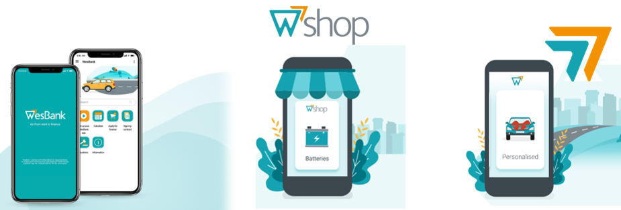

|  |  |  |
| --- | --- | --- |
| Project Details: | | |
| Project Name: | FML-3191(INC3039231) |
| Brief Description: | Automation is required when cancelling third party services (TPSC) |
| Background (Business problem articulated): | Currently we need to manually cancel all the TPSC that are linked to vehicles after termination on Miles. There after we need to send an email to the service provider for cancellation or de-installation. |
| Project Objective (What does it aim to achieve): | TPSC should be cancelled automatically upon termination of the long-term contract and the cancelation email needs to be sent automatically to the service provider. |
| Business Benefit/Value: | Customer Impact: Customer keeps on paying for the TPSC after termination of the long-term contract.  Financial-We keep on paying the suppliers for the TPSC that we are not supposed to pay them as we did not send cancelation email to the service provider. |
| Channel Value (Why should this item be placed on the channel?): |  |

|  |  |  |  |
| --- | --- | --- | --- |
| **Strategic Pillar Alignment:** | | | |
| **Book Growth Driver:** |  | Comment: |
| * Increase # Account |  |  |
| * Non-Interest Revenue |  |  |
| * Net Income Revenue |  |  |
| **Cost Optimization Drivers** |  |  |
| * Workforce Optimization |  |  |
| * Vendor Rationalization and Asset Optimization |  |  |
| * Projects Optimization |  |  |
| **Portfolio Optimization Drivers** |  |  |
| * Reduce Credit Risk |  |  |
| * Pricing/Profitability |  |  |
| * Collection |  |  |
| **FirstRand Integration Driver** |  |  |
| * Grow utilizing FirstRand Capabilities |  |  |
| * Defend utilizing FirstRand Capabilities |  |  |
| * Service utilizing FirstRand Capabilities |  |  |
| **Pro-active Risk Management Driver** |  |  |
| * Financial Stability |  |  |
| * Fair Treatment and protection of customers |  |  |
| * Prevention of Financial Crime |  |  |

|  |  |  |  |  |  |
| --- | --- | --- | --- | --- | --- |
| **Details of Initiator:** | | | | | |
| Department: | Re-marketing | | | |
| Initiator Name + Surname: | Goodman Nkosi | | | |
| Submission Date: |  | | | |
| Project Sponsor: |  | | | |
| Anticipated wish date: |  | | | |
| Project Cost Recovery (Sponsoring Business Unit/s): | | | | | |
| **Business Unit/s:** | | **Company Code/s:** |  | **% Split** | |
| FML | | 7579 |  |  | |
|  | |  |  |  | |
| **NB: If multiple Cost Centres are provided above, please indicate the methodology used for the % split:** | | | | | |
|  | | | | | |

|  |  |  |  |  |  |  |
| --- | --- | --- | --- | --- | --- | --- |
| **Business Capability Impact Assessment – Consume (C), Build (B), Migrate (M), and Decommission (D)** | | | | | | |
| **FirstID Holders** | | | | | | |
| Profile Management |  |  |  |  |  |
| Marketing Management |  |  |  |  |  |
| Relationship Management |  |  |  |  |  |
| Sales Management |  |  |  |  |  |
| Life Cycle Management |  |  |  |  |  |

|  |  |  |  |  |  |
| --- | --- | --- | --- | --- | --- |
| **Interfaces & Interactions** | | | | | |
| Interaction Interfaces |  |  |  |  |  |
| Interaction Enablers |  |  |  |  |  |
| Interaction Management |  |  |  |  |  |
| Integration Management |  |  |  |  |  |

|  |  |  |  |  |  |
| --- | --- | --- | --- | --- | --- |
| **Financial Solutions** | | | | | |
| Solution Management |  |  |  |  |  |
| Borrow Solution Management |  |  |  |  |  |
| Transact Solution Management |  |  |  |  |  |
| Invest Solution Management |  |  |  |  |  |
| Insurance Solution Management |  |  |  |  |  |
| Value-added Solution Management |  |  |  |  | |
| Telco, Device, and Service Provider Management |  |  |  |  | |
| Advice Solution Management |  |  |  |  | |
| Payments Management |  |  |  |  | |
| Stock Management |  |  |  |  | |

|  |  |  |  |  |  |
| --- | --- | --- | --- | --- | --- |
| **Business Resource** | | | | | |
| Business Management |  |  |  |  |  |
| Stakeholder Management |  |  |  |  |  |
| People Management |  |  |  |  |  |
| Finance Management |  |  |  |  |  |
| Property Management |  |  |  |  |  |
| Information Management |  |  |  |  | |
| Analytics Management |  |  |  |  | |
| Platform Management |  |  |  |  | |
| Technology Management |  |  |  |  | |

|  |  |  |  |  |  |
| --- | --- | --- | --- | --- | --- |
| **Security, Governance, Risk, and Compliance** | | | | | |
| Security Management |  |  |  |  |  |
| Governance, Risk, and Compliance Management |  |  |  |  |  |

|  |  |  |  |  |  |  |  |
| --- | --- | --- | --- | --- | --- | --- | --- |
| **Impacted Legacy Systems:** | | | | | | | |
| 3PI |  | | | WSHOP |  | CREDIT ONLINE |  |
| ACAS |  | | | CORE |  | FICS |  |
| BI |  | | | SMAC |  | FLEETACTIV |  |
| DOCUMENTUM |  | | | VAPS |  | ORACLE |  |
| FASTAPP |  | | | SMAC | **x** | OTHER( Miles) |  |
| SPIF |  | | | VAPS |  |  | |
| Other Business Areas Impacted: | | | | | | | |
|  | | |  | | |  | |
|  | | |  | | |  | |
| Forecasts (Assists with obtaining priority): | | | | | | | |
| Revenue generation: (if any) | |  | | | | | |
| Cost Savings: (if any) | |  | | | | | |
| Dependencies / Risks (Currently known): | | | | | | | |
|  | | | | | | | |
| Any Additional Information Applicable (Current stats, sentiments etc.): | | | | | | | |
|  | | | | | | | |

|  |  |  |  |  |  |
| --- | --- | --- | --- | --- | --- |
| **Cost / Effort / Duration – T-Shirt Sizing** | | | | | |
| Internal Cost | External Cost | Out of Budget Expenses (Y/N) | Estimate Received (Y/N) | Effort Total Hours | Durations Weeks/Months |

**Office Use Only**

|  |  |  |  |  |
| --- | --- | --- | --- | --- |
| Project Intake Classification Outcome | | | | |
| **Work Request** | **Medium Project** | **Large Project** | **Extra Large Project** | **Extra Extra Large Project** |

The Portfolio Manager will update the outcome of the project classification after consultation with the relevant stakeholders

*Completion of this document ensures that the item has been placed on the respective channels/product backlog for delivery. Prioritization is obtained within the respective channels/products grooming session that occurs monthly, thereafter the product/channel owner would be in position to provide a scheduled delivery date.*